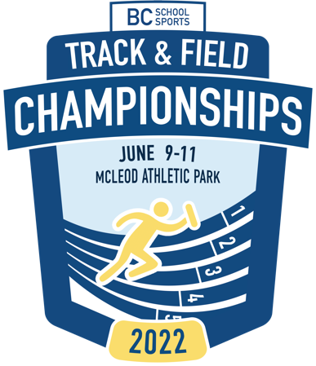

2022 BCSS Multi-Events Championship Information Package
Date: June 3-4th
Venue: Mcleod Athletic Park, 5687 Johnston Townline Rd, Langley
Entry Fee: $27.50 per athlete - 3 individual events maximum. $27.50 per relay team
Schools will be invoiced for entries by BC School Sports in the week following the championship event. Do not bring payment to the venue.
Committee Chair: Andrew Lenton, alenton68@gmail.com
Competitive Divisions: Senior, Junior, Grade 8
____________________________________________________________________________________

Entries:

Senior Entry Limit:
Maximum of 2 scoring entries per school per gender. (Only 2 score)
Schools with more than two entries MUST identify the Non-Scoring athletes on the School entry. Add NON-SCORING TO END OF ATHLETE INFORMATION

Junior & Senior divisions are scored

Entry Submissions: Through trackie.reg BC HS Multi Champs”

Use your school account to register athletes.

Registration link: www.trackiereg.com/2022BCHSMultis

Jones | Sarah | F | 9 | Semiahmoo Secondary | Semi | GR8 | GR 880m hurdles - 15.88 | Non- Scoring

Note: Grade 8 Pentathlons are Non-Scoring Events for BC Championships

Entry Deadline: Monday May 30th (10:30pm PDT)

School Volunteer Officiating – Responsibilities

Each school with athletes participating is required to assist with officiating. Duties will be collaboratively decided on at the coach’s meeting just prior to the start of competition on Day 1. Schools with athletes in the Heptathlon and Decathlon require Volunteers for Day 1 and Day 2. Schools with Pentathletes must supply volunteers for Friday.

Starting Heights:
- High Jump - Heptathlon - 1.20m (3cm increments)
- Decathlon - 1.40m (3cm increments)
- Pole Vault - Decathlon - 2.00m (10cm increments)

Technical Specifications:

 | Grade 8 Girls | Grade 8 Boys
Hurdles | 80m @ 30” | 100m @ 33”
Shot Put | 3kg | 4kg

 | Junior Girls | Senior Girls | Junior Boys | Senior Boys
Shot Put | 3 kg | 4 kg | 5 kg | 6kg
Hurdles | 80m @ 30” | 100m @ 33” | 100m @ 36” | 110m @ 36”
Javelin | 500gr | 600gr | 700gr | 800gr
Discus |  |  |  | 1.75 kg

Awards

Medals: 1st – 3rd Place

Ribbons: 4th – 8th Place

Team Points: (Junior and Senior Division only)

Points will be assigned for team scoring based on the following:

Place | Points
1 | 10
2 | 8
3 | 6
4 | 5
5 | 4
6 | 3
7 | 2
8 | 1

Event Schedule

Friday May 3rd
10:00am | 100m SB Dec | 100m JB Oct
10:20am | 100MH - 8B Pentathlon
 | 100mH - Senior Girls Hep
 | 80mH - Junior Girls Hep
10:45am | 80mH - Gr8 Girls Pent
10:45am | Long Jump SB Dec | Long Jump JB Oct
11:00am | High Jump SrG Hep
11:15am | High Jump JG Hep
11:30am | Long Jump Gr8B Pent
12:30pm | Shot Put SB Dec | Shot Put JB Oct
1:00pm | High Jump 8G Pent
1:30pm | Shot Put 8B Pent
2:30pm | Shot Put SG Hep
2:00pm | High Jump SB Dec | Shot Put JG Hep
2:30pm | Long Jump Gr8G Pent | 400m JB Oct
3:00pm | High Jump Gr8B Pent
4:00pm | 200m SG Hep | 200m JG Hep
4:30pm | Shot Put 8G Pent
5:00pm | 400m SB Dec
5:30pm | 1000m Gr8B Pent
6:00pm | 800m Gr8G Pent

Saturday, June 4, 2022
9:30am | Long Jump JG Hep
 | 110H SB Dec | 100mH JB Oct
10:30am | Long Jump SG Hep | Discus SB Dec
11:00am |  | High Jump JB Oct
12noon | Javelin JG Hep
12:30pm | Pole Vault SB Dec | Javelin SG Hep
2:00pm | Javelin JB Oct
2:30pm | 800m JG Hep
3:00pm | 800m SG Hep | Javelin SB Dec
4:30pm | 1500m SB Dec | 1000m JB Oct

Exhibition Athletes: No exhibition athletes will be allowed to participate.
Junior Athletes: Junior athletes cannot compete in the senior division unless they are competing as seniors in their zone championship & the BC High School Championship the following weekend.

